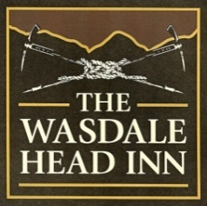

Abraham’s Restaurant

**Starters**

**

Pea & Ham Soup
With Homemade Bread

**
Seared Scallops
With Black Pudding, Prosciutto Ham & Truffle Oil

**

Twice Baked Cheese Soufflé
With Spinach Puree, Home Dried Tomatoes, Mushrooms & Pine Nuts

**

Smoked Duck Breast
With Braised Chicory, Pickled Stem Ginger, Blackberry & Juniper Jus

**

Sorbet

**Main Courses**

**

Pan Fried Seabass
King Prawn, Mussels, Samphire Fennel, Kale & Lemon Butter Sauce

**

Slow Cooked Lamb Rump
With Pomme Fondant, Spring Greens & Madeira Jus

**

Chicken Breast
With Pomme Puree, Cherry Tomatoes, Spring Onion, Chestnut Mushrooms & Tarragon Jus

**

Butternut Squash Risotto
With Spinach & Cherry Tomatoes

**

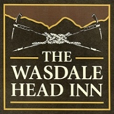

**Desserts**

**

Pistacchio Pannacotta
With Roast Peaches
**

Chocolate Tart
With Black Cherry Compote Chantelle

**

Lemon Drizzle
With Lemon Cured Puree & Raspberry

**

Cheese & Biscuits

**

Two Courses for £25.95
Three Courses for £29.95

